**Staff/Volunteer Confidentiality Agreement**

**This agreement applies to all volunteers associated with and/or involved in the activities or affairs of Making A Better Tomorrow Foundation (MABTF). This includes all activity associated with MABTF at its main office and all outreach sites locations. All data, materials, knowledge and information generated through, originating from, or having to do with MABTF or persons associated with our activities, including contractors, is to be considered privileged and confidential and is not to be disclosed to any third party.**

**All pages, forms, information, designs, documents, pictures, printed matter, policies and procedures, conversations, messages (received or transmitted), resources, contacts, e-mail lists, e-mail messages, applicants, applicant’s parents, staff or public information is confidential and the sole property of MABTF. This also includes, but is not limited to, any information of, or relating to, our staff, applicants, partners, operations and activities. This privilege extends to all forms and formats in which the information is maintained and stored, including, but not limited to hardcopy, photocopy, Google documents, automated and/or electronic form. Information, including all file information, is not be disclosed to any third party, under any circumstances, without the consent of the MABTF Board or an MABTF affiliated representative that is supervising you.**

**Any disclosure, misuse, copying or transmitting of any material, data or information, that is determined after an investigation, to be intentional will subject you to possible disciplinary action and/or prosecution, according to the procedures set by MABTF and any applicable laws.**

**My initials below represent my signature and signify I agree to these terms and will abide by, adhere to and honor all of the above.**

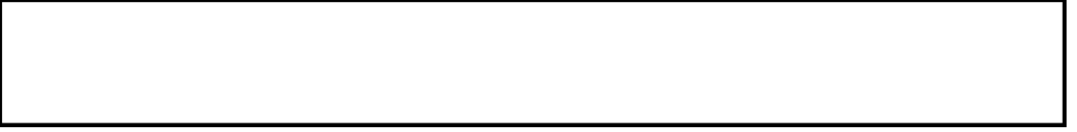

Printed Name of Volunteer

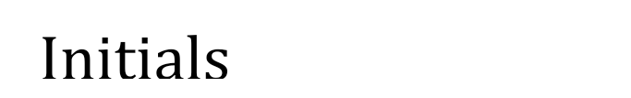

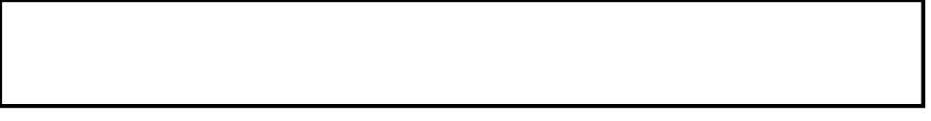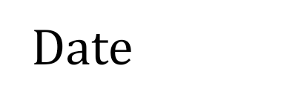

Volunteer Supervisor Name

